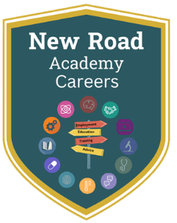
Lesson 1 – KS4 Home Learning
- Log onto Unifrog using your school email address
- If you don’t remember your password, click the “resend” button, then log into your school email account and reset your password.
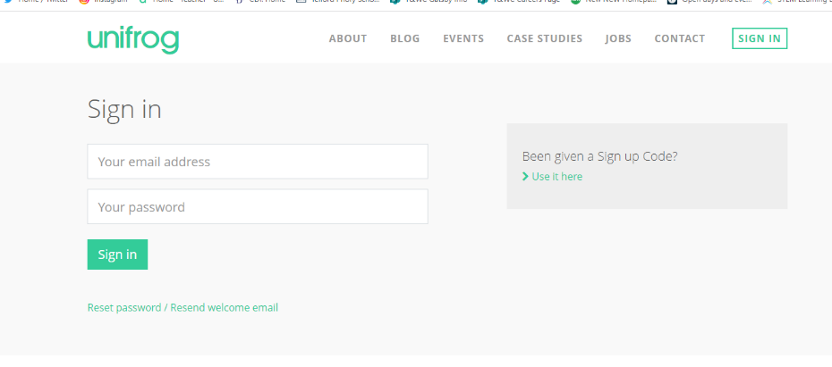

- Click on “Interests profile” and complete the quiz:
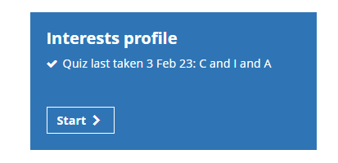
If you have taken it before, you may have to click “take the quiz again” first. Please do redo the quiz – it should be done every year.

- When you have finished, it will give you the main categories you fall into. Click “search careers library” underneath:
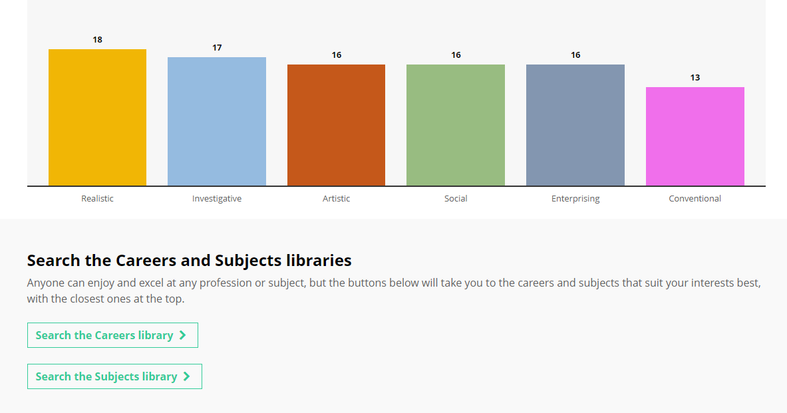
- Spend some time exploring the careers it suggests to you. You can “like” your favourites by clicking the heart in the corner. Write in the box below the first 5 careers it suggests, and whether you might be interested:

 | Career | Interested?
1
2
3
4
5

If you enjoyed this, you can also take the other quizzes available:
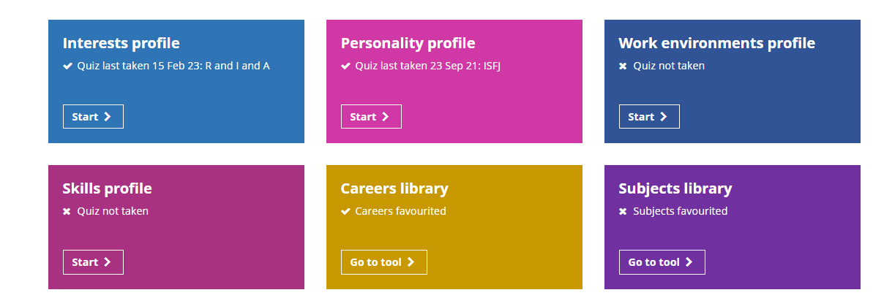

The more quizzes you do, the more refined your results will be.
- Have you thought about your next steps after New Road Academy? Which career are you interested in?

