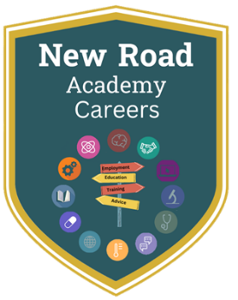
Lesson 2 – KS4 Home Learning
Writing a CV

It’s time to start (or update) your CV.
- What is a CV? How do I write one?
Check out the link here to start: MAKE YOUR CV AMAZING!! HOW TO WRITE A STUDENT CV
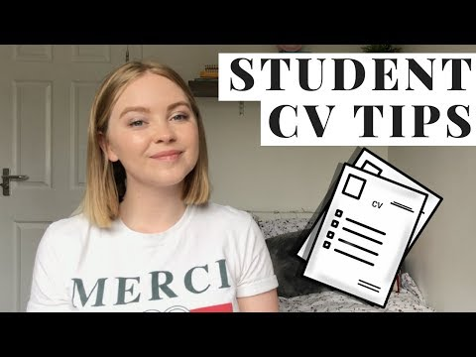
Write down the main things you should include in a CV:
1.
2.
3.
4.
5.

- Log into Unifrog and watch the video here: https://www.unifrog.org/student/know-how/cvs-resumes-and-cover-letters/how-to-ace-your-cv
The personal profile is the hardest part of your CV. This is a great summary of how to write one: https://www.prospects.ac.uk/careers-advice/cvs-and-cover-letters/writing-a-personal-statement-for-your-cv
- Have a look at the examples of a personal profile below. Notice how the good summary has lots of information at-a-glance for the interviewer.

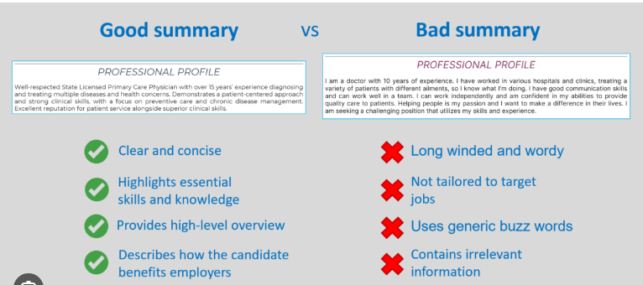

- Now, have a go at writing your opening statement below. Remember to use key information and highlight how you would be a good fit for the role.

- Next, find the CV tool on the main homepage:
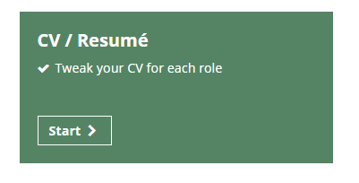
- Have a go at writing your own CV. Try and fill out each paragraph with as much detail as you can.
Once you’ve finished, you can either send it to me, your tutor or another teacher for checking. Or, you can save it and print later.

